
COMPUTER SCIENCE & ENGINEERING DEPARTMENT
FINAL REPORT (SWE 417)
Project Title:
Graduation Project Management System (GPMS)
Term: First Semester 2025-12-15
Advisor: Abdulaziz Al-Tamimi
Submitted By: | Name: | ID:
Leader | Abdullah Abdulrazzaq Al-Shammari | 2220002584
Member | Meshal Al-baiji | 2220004283
Member | Sultan Ghazi | 2220004385

Table of Contents
1. Introduction 2
2. Problem Statement 3
3. Background 3
4. Requirements and Specifications 3
5. System Design 3
5.1 Solution Concept 3
5.2 Architecture 4
5.3 Component Design 4
5.4 System Integration 4
5.5 Design Evaluation 4
6. Testing, Analysis, and Evaluation 4
7. Issues 4
8. Engineering Tools and Standards 4
9. Teamwork 5
10. Conclusions 5
Appendix A: Prototype Gaps and Action Plan 5
Prototype Screenshots 6
Login Page 6
Student Dashboard 6
Supervisor Dashboard 7
Admin Dashboard 7
Communication Module 8
References 9

1. Introduction
The prototype demonstrates that the proposed design is feasible and provides a clear user experience for all roles. Next steps include building back-end services, full integration, and comprehensive testing to ensure all requirements are met. Document all decisions and feedback during implementation for final review.
The importance of this system lies in improving efficiency, reducing errors, and enhancing user experience for all stakeholders, ultimately raising the quality of graduation projects and allowing future scalability across the university.

2. Problem Statement
The absence of an integrated system for managing the graduation project lifecycle leads to fragmented processes, difficulty in tracking submissions, and reliance on non-standard communication channels, which negatively impacts evaluation accuracy and timelines.

3. Background
While general project management platforms exist, they do not address the specific academic requirements of graduation projects, such as approvals, evaluations, and official milestone submissions. GPMS proposes a tailored solution aligned with college policies and roles.

4. Requirements and Specifications
Functional Requirements:
- Register a new project by students and manage team data.
- Submit progress and final reports through the platform.
- Supervisors review reports, provide feedback, and approve.
- Role-based dashboards (Student, Supervisor, Admin).
- Deadline tracking and notifications.
- Integrated communication system between student and supervisor.
Non-Functional Requirements:
- Usability and intuitive navigation.
- Security (multi-role authentication, permissions, data protection).
- Performance and quick response times.
- Scalability to support large user bases.
Technical Specifications:
- Front-end built using HTML/CSS/JavaScript (prototype completed).
- Proposed back-end architecture using RESTful services and relational database.
- Role-based authentication and authorization.
- Integration of communication and evaluation modules with workflow.

5. System Design

5.1 Solution Concept
The solution concept is a multi-role web platform that organizes the graduation project lifecycle: from initial registration, through milestone submissions, to evaluation and completion. It includes an integrated communication module to reduce gaps and ensure continuous documentation.
.

5.2 Architecture
The proposed architecture is three-tier: Front-end for data display and input, Application/Service layer for business logic, and Database layer for storage. The prototype for the front-end is complete; integration with back-end services will follow.

5.3 Component Design
- Login interface with role selection.
- Student Dashboard: status summary, deadlines, next deliverable, sidebar navigation.
- Supervisor Dashboard: KPIs, pending tasks, evaluation paths.
- Admin Dashboard: departmental statistics, proposal approvals, administrative actions.
- Communication module: real-time messaging, threaded conversations, timestamped records.

5.4 System Integration
Integration will use RESTful APIs between front-end and back-end services, with standardized data models and message formats. Role-specific endpoints will enforce permissions and workflows.

5.5 Design Evaluation
Prototype testing emphasized user experience and highlighted the need for a communication module and clear dashboards for each role. Design decisions will be revisited during full implementation to optimize performance and security.

6. Testing, Analysis, and Evaluation
- Functional tests for each workflow (registration, submission, review, evaluation).
- Usability tests with sample users (students/supervisors).
- Performance tests (response time, load handling).
- Security tests (authentication, authorization, data protection).
- Document results and compare against requirements.

7. Issues
Challenges during prototype phase included communication gaps and task sequencing, addressed by adding a communication module and clearer dashboards. Future challenges may involve role-based permissions and database integration.

8. Engineering Tools and Standards
Tools:
- Front-end: HTML, CSS, JavaScript.
- Design: Figma (to confirm).
- Version control: Git/GitHub.
Standards:
- RESTful API conventions.
- Security best practices.
- Accessibility guidelines.

9. Teamwork
Team Roles:
- Abdullah Abdulrazaq — Team Leader; overall coordination, design, documentation, testing.
- Meshal Al-baiji — Front-end development and UI design.
- Sultan Ghazi — Back-end development, integration, and testing.

10. Conclusions
The prototype demonstrates that the proposed design is feasible and provides a clear user experience for all roles. Next steps include building back-end services, full integration, and comprehensive testing to ensure all requirements are met. Document all decisions and feedback during implementation for final review.

Appendix A: Prototype Gaps and Action Plan
- Real authentication and role-based access control.
- Project registration form with persistence.
- File upload for reports.
- Supervisor grading workflows.
- Admin accreditation workflows.
- Notifications.
- Database schema and migrations.
- Audit trail for decisions.

Prototype Screenshots

Login Page
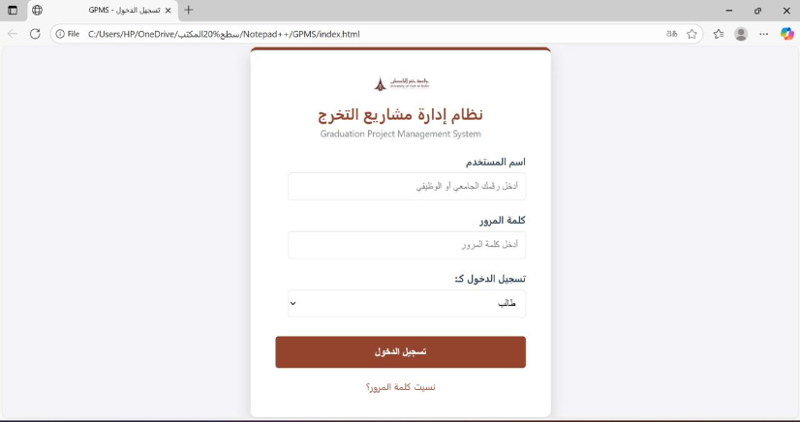

Student Dashboard
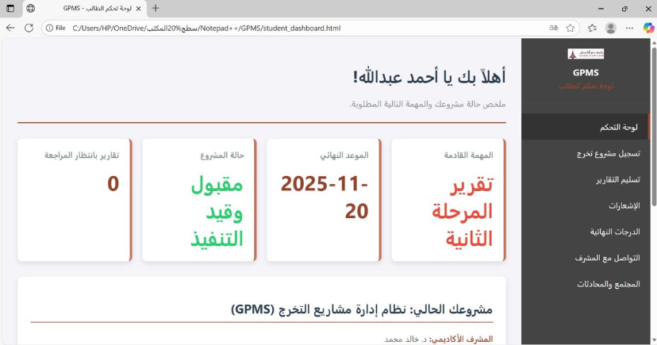

Supervisor Dashboard
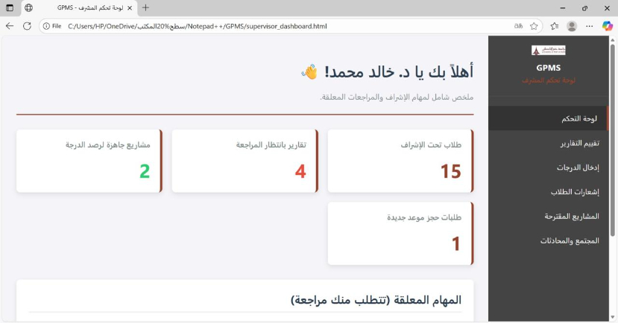

Admin Dashboard
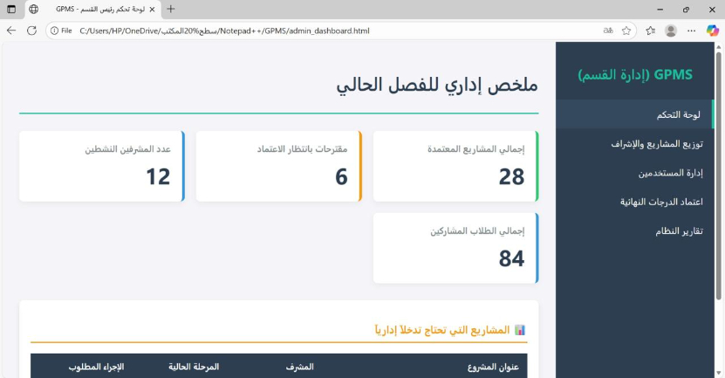

Communication Module
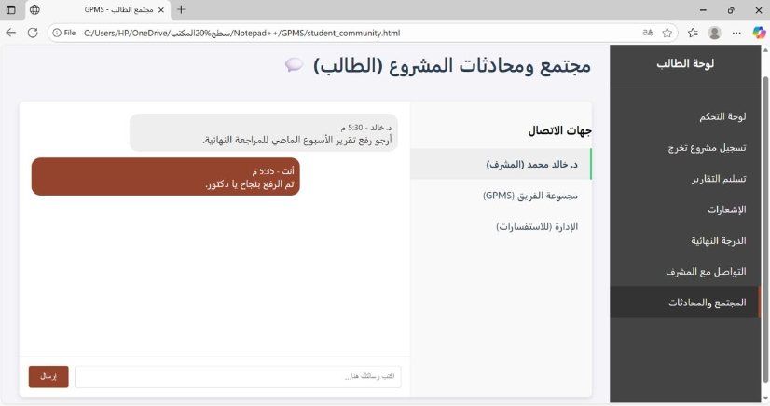

References
1. Sommerville, I. (2016). Software Engineering (10th ed.). Pearson Education.
2. Pressman, R. S., & Maxim, B. R. (2020). Software Engineering: A Practitioner’s Approach (9th ed.). McGraw-Hill Education.
3. IEEE Standards Association. (2017). IEEE Std 830-1998: Recommended Practice for Software Requirements Specifications.
4. OWASP Foundation. (2023). OWASP Top Ten Web Application Security Risks. Retrieved from https://owasp.org/
5. W3C. (2023). Web Accessibility Guidelines (WCAG) 2.1. Retrieved from https://www.w3.org/WAI/
6. GitHub Docs. (2023). Introduction to Git and GitHub. Retrieved from https://docs.github.com/
7. ISO/IEC 25010:2011. Systems and software Quality Requirements and Evaluation (SQuaRE).

